

**Addendum to the   
2022-2023 Elmira College Graduate and Professional Studies *Catalog***

**As of April 6, 2023**

**Masters of Science in Management program be reduced from 36.0 to 33.0 credit hours**

|  |  |  |
| --- | --- | --- |
| ITM 5000 | Application of Technology in Business Setting | 3.0 |
| MGT 5000 | Evaluating Research in Management | 3.0 |
| MGT 5005 | Human Resource Management and Development | 3.0 |
| MGT 5010 | Planning and Project Management | 3.0 |
| MGT 5015 | Leadership | 3.0 |
| MGT 5020 | Organizational Economics, Budget, and Finance | 3.0 |
| MGT 5025 | Business Ethics | 3.0 |
| MGT 5030 | Legal Environment of Business | 3.0 |
| MGT 5035 | Managerial Economics | 3.0 |
| MGT 5040 | Marketing Management | 3.0 |
| MGT 5045 | Organizational Behavior | 3.0 |
|  |  | **33.0** |

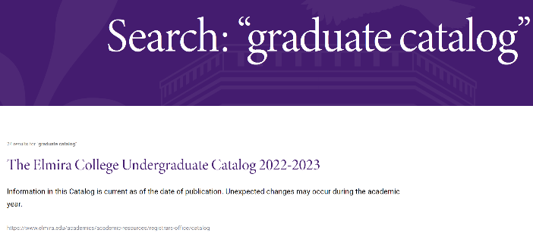**Matt, I think you may need to change this link title. When you do a search for the graduate catalog, you come up with this link that states Undergraduate in the link title, please change *to Elmira College 2022-2023 Catalogs*.** Because when you click on this and you scroll down you then also see the Graduate Catalog. Please create whatever you would need to do for the searches for both Undergraduate and Graduate Catalogs.

<https://www.elmira.edu/academics/academic-resources/registrars-office/catalog>

## Then create a new addendum like we list for the undergraduate - this will be new to the Graduate area: <https://www.elmira.edu/academics/academic-resources/registrars-office/catalog>

## Current Graduate ~~Bulletin~~ and Professional Studies Catalog

Information in this ~~Bulletin~~ Catalog is current as of the date of publication. Unexpected changes may occur during the academic year. The listing of a course or program in this ~~Bulletin~~ Catalog, therefore, does not constitute a guarantee or contract that the particular course or program will be offered during a given year.

[**GRADUATE ~~BULLETIN~~**](https://www.elmira.edu/files/assets/ecgradcatalog2022-23revised9-28-2022.pdf) *this button needs to state: Graduate and Professional Studies Catalog*

Create this statement:

## Addendum

* There is an [**addendum to the 2022-2023 Elmira College Graduate and Professional Studies Catalog**](https://www.elmira.edu/files/assets/revised-ecaddendum22-23undergradcatalog-2-14-23.pdf) listing recently approved change in credits for the Masters of Science in Management.

MATT - the information for the Addendum is listed at the beginning of this document and a separate pdf file for you to link to and for your guidance.

**\*\*\*\*\*\*\*\*\*\*\*\*\*\*\*\*\*\*\*\*\*\*\*\***

**THEN we have to have these additional areas updated as well:**

[**https://www.elmira.edu/academics/graduate-programs/overview**](https://www.elmira.edu/academics/graduate-programs/overview) **= clarify with Matt started here for the Graduate Management information**

<https://www.elmira.edu/academics/programs/management-ms> for Matt

This is the information to list on elmira.edu - the only change is to the credits (is highlighted):

*Elmira College’s Master of Science (MS) in General Management is designed around performance-based experiences that will build real-world skills and knowledge to prepare you for success in any industry.*

*The program* ***consists of 33*** *credits of required coursework, including the capstone graduate seminar. It is designed for completion within a 15-month or a two-year time frame. For more information, please contact*[***graduate@elmira.edu***](mailto:graduate@elmira.edu)*.*

General Management

The Master of Science (MS) in General Management is designed for individuals planning a career in management, current managers, and individuals with aspirations for career advancement. It requires satisfactory completion of 12 courses totaling **33 semester credits**. There are no electives. The degree is comprised of performance-based learning experiences intended to develop the essential knowledge and skill competencies required for general managers.

<https://www.elmira.edu/academics/programs/management-ms/course-requirements> for Matt

**All the changes listed below are listed on the site: “Core Requirements”**

Students must complete the following graduate-level management courses:

* **ITM 5000 Application of Technology in a Business Setting | 3.00 Credit Hours - *[Matt, please move this course to the top of the list]***
* MGT 5000 Evaluating Research in Management | 3.00 Credit Hours
* MGT 5005 Human Resource Management & Development | 3.00 Credit Hours
* MGT 5010 Planning & Project Management | 3.00 Credit Hours
* MGT 5015 Leadership | 3.00 Credit Hours
* MGT 5020 Organizational Economics, Budget & Finance | 3.00 Credit Hours
* MGT 5025 Business Ethics | 3.00 Credit Hours
* MGT 5030 Legal Environment of Business | 3.00 Credit Hours
* MGT 5035 Managerial Economics | 3.00 Credit Hours
* MGT 5040 Marketing Management | 3.00 Credit Hours
* MGT 5045 Organizational Behavior | 3.00 Credit Hours
* **~~MGT 6000 Graduate Seminar in Management | 3.00 Credit Hours~~**

**General Business Concentration**

* Business Ethics
* The Legal Environment of Business
* Managerial Economics
* Marketing Management
* Organizational Behavior

**Total credit hours = ~~36~~ 33.0 credits *[Matt, after the General Business Concentration listing, the statement changes to 33.0]***

**Spring II**

MGT 5035 Managerial Economics  
**~~MGT 6000 Graduate Seminar in Management~~**

**Summer II**

MGT 5000 Evaluating Research in Management  
**~~MGT 6000 Graduate Seminar in Management~~**